העבודה כוללת הערות המנחה במצב סקירה
String theory
תורת המיתרים
מגישה: XXX

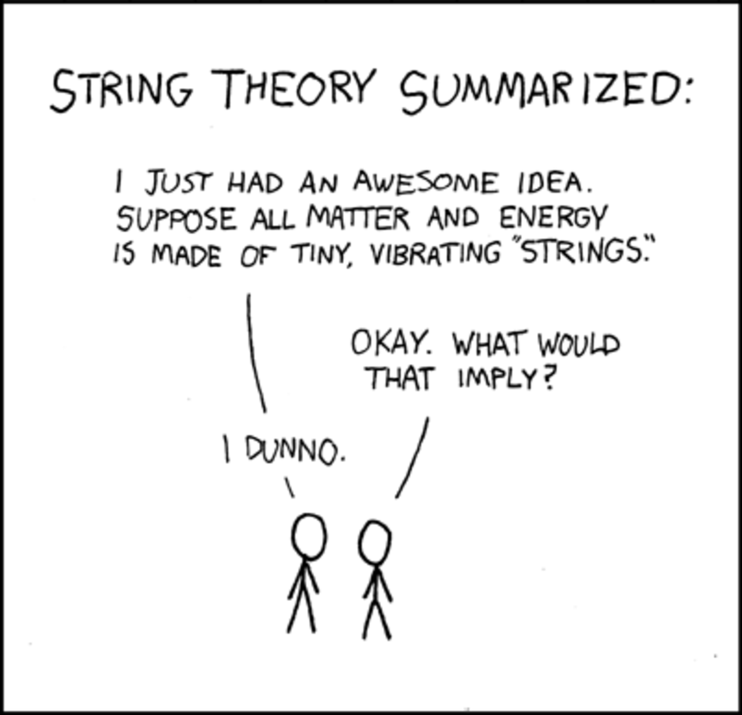
מנחה: פרופ' מוטי דויטש

תוכן עניינים:
What is string theory? ………………………………………………………3
How did it come to be?............................................................................5
What is supersymmetry?.........................................................................6
What are bosons and fermions? (And what are the other particles we should know about?)…………………………………...…………………………………7
M theory, and extra dimensions…………………………….….…………..8
What about the extra dimensions we’ve mentioned?.........................10
Loop quantum gravity, and the Theory of Everything……….……….13
In conclusion (What’s next, and a short summery)…..……………….…….14
References…………………………………………………..………….…….15

What is string theory?
In a nutshell, String Theory comes from our never ending quest as scientists, and humans, to understand, just what is our world made of? It’s a question every branch of physics tries to answer.
The theory suggests a solution: the most fundamental building blocks of our universe are tiny, vibrating strings (So tiny, in fact, that if we attempt looking at them with the help of the tools currently in our disposal, they will appear as point particles). and apparently we can use the theory to better understand and even solve many other mysteries, like dark matter, and black holes (as we’d like to know, how do quantum physics and the force of gravity come together within them?[1]).
Dealing in neutrons and protons, string theory is also of interest to nuclear physics.
Here’s some intuition: If we take a piece of matter and keep dividing it into smaller pieces, we will eventually find ourselves with something that up until about 100 years ago, was thought to be undividable: the atom.
It’s been almost a century since we’ve discovered that atoms can be divided- into electrons, and protons, neutrons and gluons, that keep the last two ‘glued’ together in a tight nucleus[1].
While the electron is presently considered an elementary particle (though it would be more accurate thinking of it as a quantum cloud [2]), protons and neutrons can be divided into different combinations of three quarks (proton is two UP quarks and one DOWN quark, and a neutron is made up of one UP and two DOWN quarks).
And this is where string theory comes in: if we look inside the quarks, we will find tiny little strings, both ‘open’ and ‘closed’, vibrating and interacting with each other (for example: two strings can form into one, or one string can break into two strings [3]); and depending on their shape and their frequency, we get the particle at hand. But not only that: any and all aspects of a particle- its mass, charge and anything that makes the particle what it is, is determined by the vibration of a string.
In some versions of a string theory, for example (of which there are several, unless we are discussing M theory- but more on that later), an electron can be described as a closed string (a loop), while others claim that it is just a part of a string, held in place by its ends.
One other such particle that can also be determined by the vibration of the string is the graviton: a particle that carries gravitational force.
Considering that this particle is connected to the force of gravity, and that it’s a quantum mechanical particle (i.e. has properties that are explained through quantum mechanics rather or more accurately than particle physics and Newtonian mechanics), we may claim that string theory is that of quantum gravity and that the two approaches may possibly be bridged at last[3].
Another quality string theory hasis that it may just give us a Theory of Everything: a single mathematical description of both matter and the four fundamental forces (because it both explains gravity, and particles).
If correct, string theory can describe physics on a better energy scale than the one we can currently prove by testing.
We assume that if we manage to get to the energy scales that the theory describes, we’ll be able to accurately describe all kinds of fantastical phenomenon, like extra dimensions (more on that later).

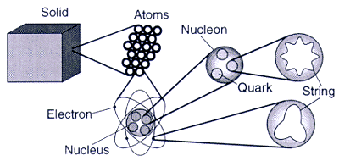a general representation of how matter is broken down into strings
How did it come to be?
So what’s the history behind string theory? Who made the first steps in its formulation?
String theory began as a mistake. It started off as what later turned out to be an incorrect model for hadron physics.
It all started back in 1968, with the work on the Veneziano Model (created by Gabriele Veneziano): a mathematical formula describing how particles bounce off of each other (and how their scattering amplitudes can be described using beta function).
Veneziano was working on a theory of strong nuclear force, and found that he could describe the strong interaction between particles [3][5]
What seemed like a big accomplishment at the time was later on abandoned in favor of quantum chromodynamics, and in the 1970s, theoretical physicists working on string theory were considered to be pseudo-scientists at best, and weren’t taken seriously.
It was only in later years that it was realized that the same properties that prevented string theory from being an accurate theory in the field of nuclear physics, made it a good fit for the field of quantum mechanics, and a theory of quantum gravity (as the phenomenon it predicted were better suited for smaller scales).
It was further developed and refined by many different physicists, and the work on it continues just as vigorously today.
First called the ‘Bosonic’ string theory (only dealing with boson particles), string theory today is known as the ‘superstring theory’- when the ‘super’ part comes from supersymmetry, and including not only bosons, but also fermions.

What is supersymmetry?
In order for a string in string theory to be able to mimic both force particles like the previously mentioned gluon, and matter particles like quarks and electrons (ones we’ve already established to be elementary particles that are a step before strings), string theory it must accurately predict all the different types of elementary particles that are in existence. [6]
It does so in the following way: according to the theory, for every force particle (photons, gluons…), there has to be a corresponding matter particle, behaving in a certain way- and the other way around.
There is a demand for a symbiotic relationship between any and all force, and matter particles (and here we have another hint to the highly sought after theory of everything, unifying all that exists in nature).
This highly theoretical relationship was named supersymmetry, and it’s where the ‘super’ comes from the aforementioned superstring theory: it deals with strings that have just such a property.
And so, for example, for every electron we predict a selectron, and so on. And the selectron will be a selepton, or sfermion (once again we have the‘s’ indicating supersymmry).
This is, of course, like all of string theory, highly hypothetical.
There is currently no evidence of such symmetry, but one possible explanation is that these partner particles are predicted to be too massive to be observed in the experiments conducted in the LHC in CERN, thus far.
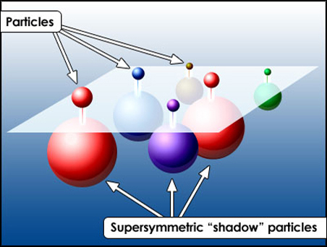 an image depicting particles and their symmetric partners
What are bosons and fermions? (And what are the other particles we should know about?)
String theory claims that all the elementary particles can be divided into either fermions, or bosons.
Let’s start with the basics: there are 12 elementary particles of matter, and we call them all fermions (elementary particles like the electron and the quark, ones which we can’t divide into smaller particles- particles, and not strings; It’s a matter of scale).
These include the six flavors of quarks (up, down, strange, charm, bottom, top), and six leptons (electron, muon, tao and three corresponding neutrinos). [7]
They have a half-integer spin (1/2, 3/2, 5/2…), and make up protons and neutrons, making them fermions as well.
This means fermions are the particles that compose the matter around us.
Bosons, on the other hand, have an integer spin (0,1,2…) and there are 5 of them: four gauge bosons, and one Higgs boson.
In the gauge bosons, we have the photon, the gluon, the Z and the two W bosons (they have the same mass and the same numerical electric charge, 1: either negative, or positive).
Those are the vector bosons.
The last part is the recently discovered Higgs boson, completing our standard model of particle physics.
In short, it was predicted, back in the 60s, that there must exist another elementary particle that we are unable to detect (again, up until recent years- 2013, to be exact). Such a particle was suggested as a solution to the conundrum that certain elementary particles have a measurable mass, while in theory they should have none.
The Higgs boson is a scalar boson (one whose spin is 0). [visual aid (1) on page 13]
M theory, and extra dimensions
String theory had several versions.
Then in the beginning of the 1990s, M theory was proposed, beginning the second superstring revolution, morphing all the previous versions into one, suggesting a definite number of dimensions [3]
String theory predicts more dimensions than the ones we can perceive naturally; 11 (or 10, depends on whether you start from 1 or 0), to be exact.
And while M theory itself isn’t a part of string theory, it is nevertheless very much relied upon.
Before the 1990s, string theorists were already familiar with superstrings, connection of strings and spacetime, and they have developed the concept of ‘compactification’: making the six extra dimensions predicted by superstring theory into the four we are comfortable with: three of space, and one dimension of time.
This encompassed all the basics: gravity, photons, electros and the works.
But it still didn’t mirror correctly the world. There was something missing.
There were inaccuracies in supergravity (when we are left with but the lowest of energy of the vibration modes of superstrings), and they we still lacking a coherent and complete description to strings’ interaction with one another.
So after a time when many parts didn’t fit quite right, in 1995, Edward Witten merged the five reigning theories, and the 11-dimention supergravity, and created M theory.
Suddenly, strings weren’t regarded as the complete story, and branes took center stage.
We can look at a brane as a multi-dimensional string.
While a string, open or closed, becomes a ‘1-brane’, and a point particle would be a ‘0-brane’, and so one.
A brane can have any number of special-dimensions, and when we add a dimension of time, we get what is called a membrane, a 2-brane; a surface.
Under some conditions, branes could be described as zero-temperature black holes. [3]
(Speaking of black holes and the cosmos, string theory has a connection to dark matter, through supersymmetry: one of the particles the principle predicts is very small and very heavy, making it similar to our idea of dark matter)
And so suddenly we had a definite number of dimensions we had to take into account.
So to sum up: M theory has united the five string theories that came before it into one, and made branes a thing of importance- as well as determining that there are 11 dimensions.
But what are the different dimensions? How can we begin to perceive them?
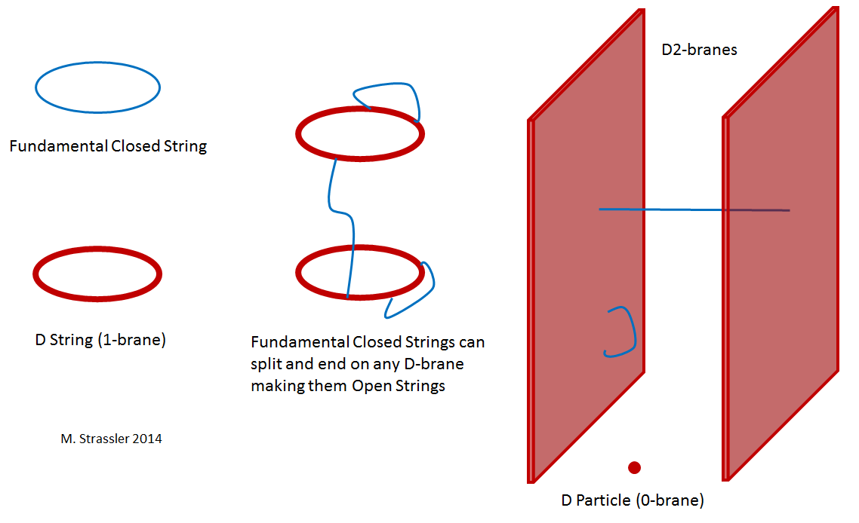
What about the extra dimensions we’ve mentioned?
If we look at a simple point in space, like a particle or the most simple of dots, we can observe that it has no size, and therefore 0 dimensions.
(Note: in this explanation we will end up with 10 dimensions, as we’ve started with 0. We can do the same starting with 1 being the point, and have 11 dimensions, making the exact number, be it 10 or 11, arbitrary). [6][8]
If we take another point in space and connect the two with a line, we will get an object which has 1 dimension- only length (assuming the two dots are on an imaginary vertical axis).
It has no width or depth.
We will start by adding another line across it, so that our 1 dimensional object becomes 2 dimensional, obtaining width.
We may continue by drawing more lines, making a Necker cube.

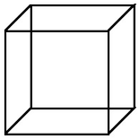the Necker cube, representation of three dimensions

Our dot has now become a three dimensional object, having depth.
Being three dimensional creatures ourselves, this is how we perceive reality; though we experience time (the 4th dimension), we cannot fathom it- we only see it in succeeding ‘parts’, in a linier fashion- much like a two dimensional creature will be expected to see us.
And so, every dimension builds on the previous ones, and an object- or creature, of the nth dimension, won’t be aware of his actions in the n+1th dimension (like an ant traveling on a Mobius strip, thinking it continues being on the same side).
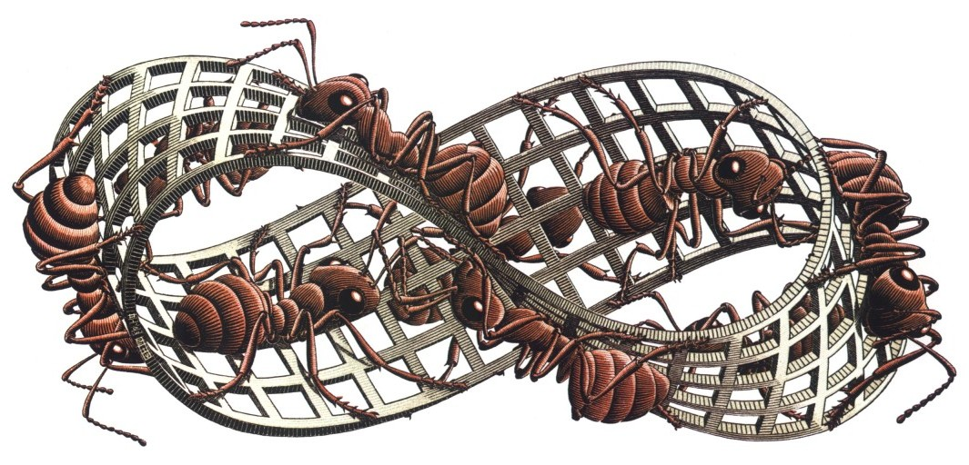
Ants on a Mobius strip

All we have to do in order to receive the next dimension, is treat the current dimension as point in time, and think- how will it look connected to another point-like object of the same dimension?
We will also need to be able to imagine what another point itself will look like.
Moving to the next dimension above, we will need to ‘fold’ our current dimension through it.
In summation, our dimensions will be as follows (each an extension of the previous ones):
1st: Length
2nd: Width
3d: Depth
4th: Time
5th: Parallel universes/realities
6th: Connections between the aforementioned parallel universes
7th: Different realities (branching from different connections between universes- bridges to bridges, shall we say)
(Side-note: to us, all these different realities will look like infinity)
8th: The bridges connecting the different realities
9th: Folding 8 to access the next dimension (9)
The 10th dimension (or 11th), is that on which, according to string theory, superstrings vibrate.
In this dimension, we have all the other possible universes and dimensions contained.

Loop quantum gravity, and the Theory of Everything
String theory isn’t the only theory attempting to explain how quantum theory better describes the universe and gravity, and tries to unify the two.
We have, for one, the theory of loop quantum gravity, or LQG for short. It too attempts to unify quantum theory and gravity. [ST for dummies]
According to LQG, our world can be explained by a network of loops of gravitational fields, called ‘spin networks’. [9] With time, they are theorized to transform into ‘spin foam’).
While both theories intend on unify general relativity (which is a theory of spacetime but not of quantum theory) and the standard model of particle physics (the theory dealing with three of the four fundamental forces: electromagnetic, the strong and the weak forces), they disagree on a few important issue: for starters, our elegant supersymmetry principle doesn’t work for LQG (or rather, LQG doesn’t bother with it).
But the most important differences are these: LQG doesn’t suggest more dimensions over the four we have, and it isn’t intent of unifying all four forces, like string theory.
This makes string theory the leading theory in becoming a Theory of Everything, explaining and predicting any part of our universe.
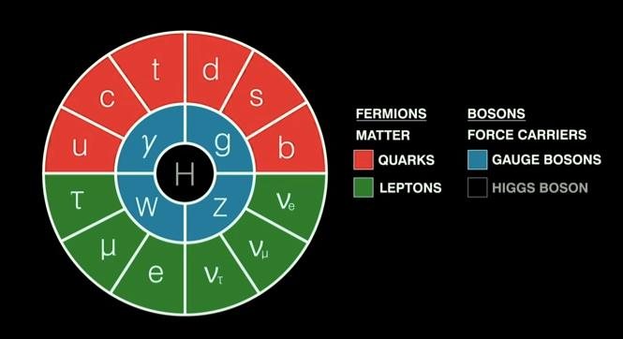
[visual aid (1)]

In conclusion (What’s next, and a short summery)
String theory research is rather abstract. It’s a as of now non-disproved theory that has the potential to unify all of physics, but how does it work? No one really knows to say, exactly. Any physicist worth their labcoat will be careful in making any bold claims without a disclaimer, as, again, string theory hasn’t been proven, and it is a fairly new and bizarre and counterintuitive field of study; but it hasn’t been disproven, either.
Previously conducted experiments in CERN haven’t produced any data contradicting it, and it remains a favorite ‘theory of everything’, surpassing loop quantum gravity, attempting to give us a better picture of our universe.
String theory predicts a very fundamental part of spacetime: the number of dimensions it has to have.
It explains how elementary particles differ from one another in a very elegant manner, providing us with an explanation to the different spins, masses, flavors etc (by having different modes of vibrations).
What we’d like to see in the future is some definite proof of the theory (maybe the shadow particles from supersymmetry), which will help us not only in better understanding subatomic particles but also dark matter, as well as black holes.
If it keeps developing further, we might discover proof of gravitons- helping us cement string theory as a leading theory of quantum gravity.
String theory is important because it provides us with a mathematical description of the universe, ranging from the smallest particles know to us, to the biggest clusters of stars.
We remain hopeful that in our lifetime we’ll get to see the LHC produce such proof (just like it did with the Higgs Boson).
And if not, then maybe the next collider. Or the one after that.

References, in order of appearance: Books and Scientific papers as well as some youtube videos and internet pages

[1] https://www.youtube.com/watch?v=MlDd2HtFfPU Amanda Peet Public Lecture: String Theory Legos for Black Holes

[2] https://www.youtube.com/watch?v=eGxPGgPdTVw String Theory Explained [by Brian Greene]
[3] The Little Book of String Theory, by Steven Gubser
[4] Di Vecchia, P. (2008). "The Birth of String Theory". In Gasperini, Maurizio; Maharana, Jnan. String Theory and Fundamental Interactions – Gabriele Veneziano and Theoretical Physics: Historical and Contemporary Perspectives
[5 ] https://www.youtube.com/watch?v=hEOve55Votk (M theory, String Theory, Parallel Worlds - Dr Michio Kaku )
[6] https://www.perimeterinstitute.ca/research/research-areas/quantum-fields-and-strings/more-string-theory Perimeter institute
[7] Particles and Fundamental Interactions: An Introduction to Particle Physics, by Braibant; Giorgio Giacomelli; Maurizio Spurio
[8] 11 dimensions, explained https://www.youtube.com/watch?v=p4Gotl9vRGs
[9] String theory for dummies, by Andrew Zimmerman Jones (Author), Daniel Robbins (Contributor)
* A Brief History of String Theory: From Dual Models to M-Theory, by Dean Rickles
* TASI Lectures on Black Holes in String Theory, Amanda W. Peet, hep-th/0008241

* The Elegant Universe: Superstrings, Hidden Dimensions, and the Quest for the Ultimate Theory, by Brian Greene

